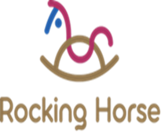

Mission statement
At Rocking Horse Nursery we strongly believe all children are individuals and amazing learners, these little ones are indeed our future and our aim is to provide them with the best opportunities to start their early year’s journey. All children deserve a safe, secure and happy environment to explore feely and at their own pace.
At Rocking Horse nursery each child’s learning and development will be supported to their full potential and their individual interests are nurtured. We aspire for all our children to have a sense of belonging to be valued and apart of the Saint Nicholas’s growing family and their future.
Our vision is to provide enriched opportunities to allow children to develop the knowledge and learning behaviours they will need as they grow up and contribute to them succeeding in later life. The children’s learning is led with the balance of child and adult-initiated experiences which promote learning across the Early Years Foundation Stage.
Our EYFS aim is to provide quality of opportunity, a secure foundation, quality and a consistent approach to the children’s learning and provide effective partnership working.
Our outstanding nursery team are caring, friendly and fun, they have high aspirations for our little ones; and they will ensure high quality provision is founded on the individual needs of each child.
Our extended outdoor learning spaces within the school grounds are an additional provision that we value and recognise with how fortunate we are to have this quality of space. These areas provide additional opportunity to enrich our children’s learning experiences.

